**BUSINESS ANALYSIS PROJECT**

**FRAUDULENT CREDIT CARDS TRANSACTIONS ANALYSIS**

**ASSESSMENT OF THE SITUATION**

1. **INTRODUCTION**

Business analysis is used at a higher level of a company to define its strategy in the decision making process. The big deal is to understand what is behind the needs expressed by the client.

In this project, we had to use skills, technologies and practices of iterative and continuous investigation of the past performance of a bank in order to obtain information for setting a solution as Business Analyst. All this is based on databases and statistical methods.

1. **SYSTEM ANALYSIS OF PROBLEM (SAP)**
   1. **Define the Problem**

The context is that the bank receives complaints from its customers victims of fraudulent credit card transactions.

The problem is that the bank doesn't have an idea about how to implement a strategy for stopping fraudulent credit card transactions.

Customers who used their credit card continue to have their money stolen, they are angry and they want this to stop, otherwise, The bank will lose credit and money.

* 1. **Reviews of Stakeholders**

|  |  |  |
| --- | --- | --- |
| **Stakeholders** | **Role** | **Impact** |
| Customers | They give cash to save and have some loan from the bank | They have had their money stolen and want to have it back. |
| Entreprise | They save cash and have loan from the bank | They have had their money stolen and want to have it back. |
| Electronic products provider | They provide computers, software, security systems and electronic cards. | They sell electronic cards but if they still are stolen, they can lose the bank as client |
| Senior Management | provide leadership to the  banking staff, provide a high level of performance of their bank | This situation is affecting them more and more, their customers do not trust them with their money anymore. |
| The Media | Organizations that supply news and information to the public, such as newspapers, radio, television, and the Internet | They are afraid of being stolen and notify people about the risk of being stolen. |

* 1. **Measures or Performances**

|  |  |
| --- | --- |
| **Profit margin** | Is a measure of the bank’s profitability |
| **Total Volume Of Accounts** | The total number of accounts managed by your bank |
| **Client Survey Score** | Bank performance as measured by customer feedback |

* 1. **Importance of the Problem**

This problem is important for the general management because it can eventually lose customers and money. Other companies will certainly not want to have a bank account with this bank. It will also lose future customers due to lack of trust. Basically the bank risks bankruptcy due to lack of credibility.

* 1. **Methodology**

During this phase we first cleaned the data and got rid of un-informative variables, then we group the variables in function of their types and basic descriptive analysis was effectuated. Then we look for relation between those variables by plotting them one to the other and using a chi-square statistical test, for categorical variables We used python to do so, clean the data and generate descriptives and graphs.

The bank’s records and the information given by the Senior management allowed us to harness a clear understanding of what was happening. A review of the quantity and quality of the data we received allowed us to estimate the feasibility of the project

* **SWOT**

**Strength**

* The bank's wishes to provide better customer service.
* The bank’s record

**Weakness**

* Inaction before media critics
* Weakness in detecting fraudulent transactions

**Opportunity**

* Measure the impact of financial risks on profitability
* The senior management hire a Business Analyst (BA) to solve the problem

**Threats**

* Profit margin decreases
* Risk of bankruptcy
* Loss of confidence from other companies
* Loss of credibility
* **Relevants Analytics**

Analysis has made with two types of variables :

* categorical variable

Age, gender, category, fraud

* numerical variable

step, costumer, merchant, amount

* **Insights**

On over 593,000 transactions, only 1.2% were fraudulent

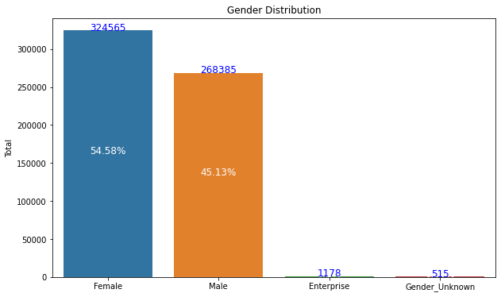

* Female(54.58%) are made more transaction than woman (45.13%)

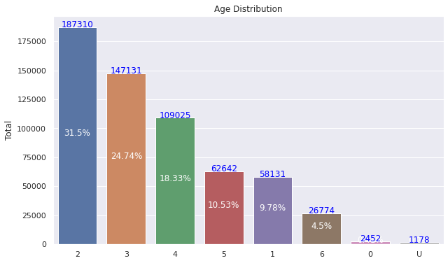

In this graphic, we can see that young people(26-35, 36-45, 46-55) and older people between 56-65 have made more transactions than others.

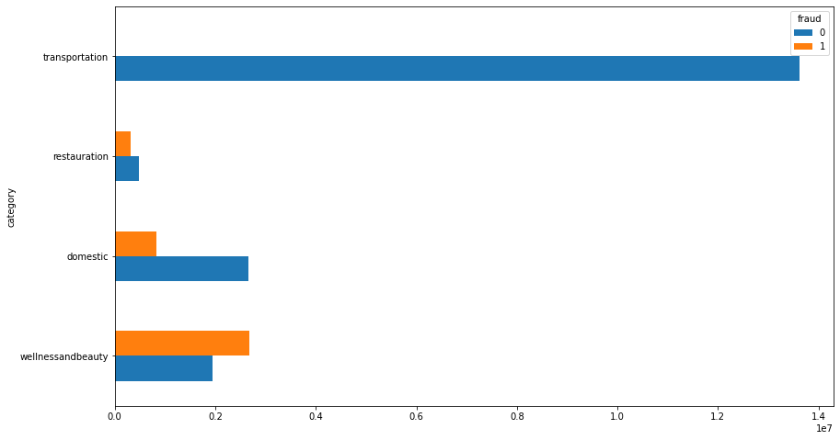

There is no fraudulent transaction in the Transportation category. The more fraudulent transaction has been made in the wellandbeauty category.

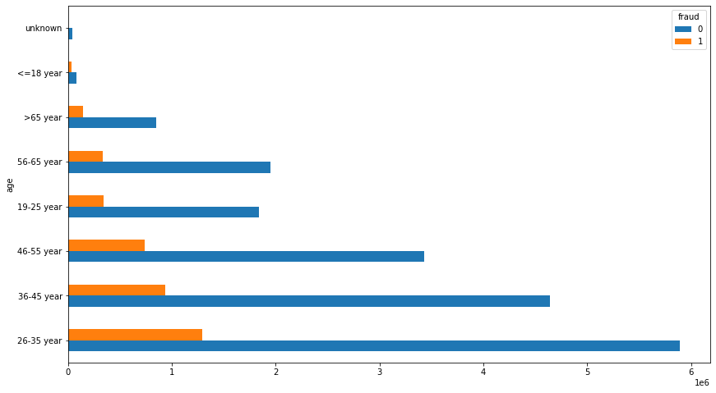

The 26-35, 36-45 and 46-55 groups are much more likely to be victims of fraudulent transactions than others.

**Alternative Solution**

* **Solution I**
* **Detection system**

The first solution that should be presented here is using mobile phones as secure transaction systems able to protect customers from fraud.

* **How ?**

Using a three-level identification system : Customer ID - PIN - Code

The first one could be the customer ID, once entered, sends back a PIN request. The PIN request, Once entered, asks the user for a confirmation code that only himself knows.

**Benefits Disadvantages**

This solution is enough secure This solution cost money

* **Solution II**

**Using bank book**

This project identifies the circuit fraudulent transaction, we propose to the bank this following actions :

Exchange credit cards from the age group of 25-36 years with a bankbook : Transactions are validated only when users give two code numbers.

**Benefits Disadvantages**

This solution cost money This solution is not update for young people

The user loses the bankbook easily This solution cost money

* **Solution III**

regarding to the circuit fraudulent transaction, we propose to the bank this following actions :

The bank should conduct an awareness campaign on the use and security of bank cards among age groups likely to be victims of fraud (25-46), especially among women.

**Benefits Disadvantages**

This solution will help this group to be aware This solution cost money

**Recommendations**

In general, however, debit and credit card fraud occurs when your card or card information is stolen and used to make unauthorized charges, then the bank can suggest some protectives measures to clients:

* Do not share your card details with others ;
* By being careful not to share our personal information, it won't fall into the hands of the wrong people. Even sharing with trusted people can be wrong, we have no idea where that information might go ;
* Hire a public relations manager
* Use only secure websites.
* Only make online purchases through trusted websites. That way you won't have to deal with trackers.
* Minimize sharing personal information online.
* Be more careful in use credit card

**Team member**

***Camille JACKYVENS***

[leamic.cj@gmail.com](mailto:leamic.cj@gmail.com)

***David LOUIS***

[davidlouis301@yahoo.fr](mailto:davidlouis301@yahoo.fr)

***Yvesna MARCELIN***

[yvesnamarcelin48@gmail.com](mailto:yvesnamarcelin48@gmail.com)

***Moïse MASSON***

[massonmoise2@gmail.com](mailto:massonmoise2@gmail.com)